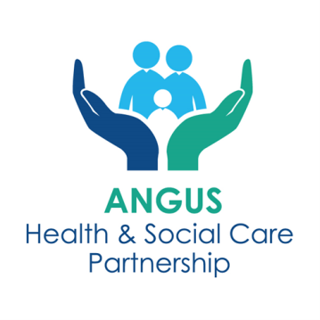**xs]**

**Angus Mental Health & Wellbeing Enhanced Community Support (ECS) Hubs**

**PROTOCOL FOR ALL REFERRERS AND HUB STAFF**

The Mental Health and Wellbeing Enhanced Community Support (ECS) Hub is a screening hub to manage referrals for adults who need additional support or specialist care and treatment for their mental health and wellbeing, self- harm and/or substance use. Each of Angus’s four localities has an ECS Hub:

* North East Angus – Brechin, Edzell, Montrose
* North West Angus – Forfar, Kirriemuir, Letham
* South East Angus – Arbroath & Friockheim
* South West Angus – Monifieth & Carnoustie

**REFERRAL PROCESS**

**Who Can Refer:**

* GPs, Advanced Nurse Practitioners, Practice Nurses, Minor Injury Units (MIIUs), other agencies, and self-referrals.
* Urgent referrals should follow standard procedures and do not go through the ECS Hub.
* Referrals for Psychiatry of Old Age (POA) - follow usual standard GP referral procedures direct to the service. These referrals do not come through the ECS Hub

**Self-Referrals:**

Referral forms are available online via GP practice websites or in paper format from GP receptions. Adults can complete the referral form and submit it by:

* Email to the dedicated locality hub address.
* In person at their GP practice reception.

**Processing Referrals:**

* GP practice staff forward completed forms to the hub email.
* Referrals submitted after 9am are reviewed the following day.

**Process:**

Referral forms and information sheets are available in **Appendices 1-4**.

The Information Sheet (Appendix 4) should be given to everyone who is referred to the Hub prior, either as a paper copy, text message, or by referring them to the GP Website.

Daily screenings follow the Screening Tool Pathway - **Appendix 5**.

**ROLES & RESPONSIBILITIES**

**ECS Lead**

* Chair daily hub meetings using the screening tool pathway.
* Delegate and ensure all actions are completed.

**Administrative Staff Member**

* Collate referrals to be discussed at each days Hub.
* Check for referrals at 9am, 11am and 3pm.
* After screening hub - transfer cases to the correct team on Trakcare.
* If this is a CMHT routine referral. Format and send patient letter and agreed enclosures.
* Fill in excel referral database with all required information.

**All Hub Attendees**

* Attend and participate in daily screening Hub.
* Review and discuss referrals using the Screening Tool Pathway.
* Read out referrals for consideration.
* Check online records and agree outcome of referrals.
* Agree who will make contact and waiting well process for referrals.
* Forward email referrals to the agreed team/service, saving a copy of sent email into relevant mailbox subfolder.
* Update relevant electronic systems for your team/service.

**Appendices**

Appendix 1 – How to Make a Referral

Appendix 2 - Referrer Information Sheet

Appendix 3 – Referral Form

Appendix 4 – Information Sheet

Appendix 4a – Information Sheet – Easy Read Version

Appendix 5 – Screening Tool Pathway

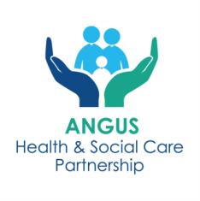**Appendix 1**

**Angus Mental Health and Wellbeing ECS Hubs**

**PRIMARY CARE REFERRAL PROCESS**

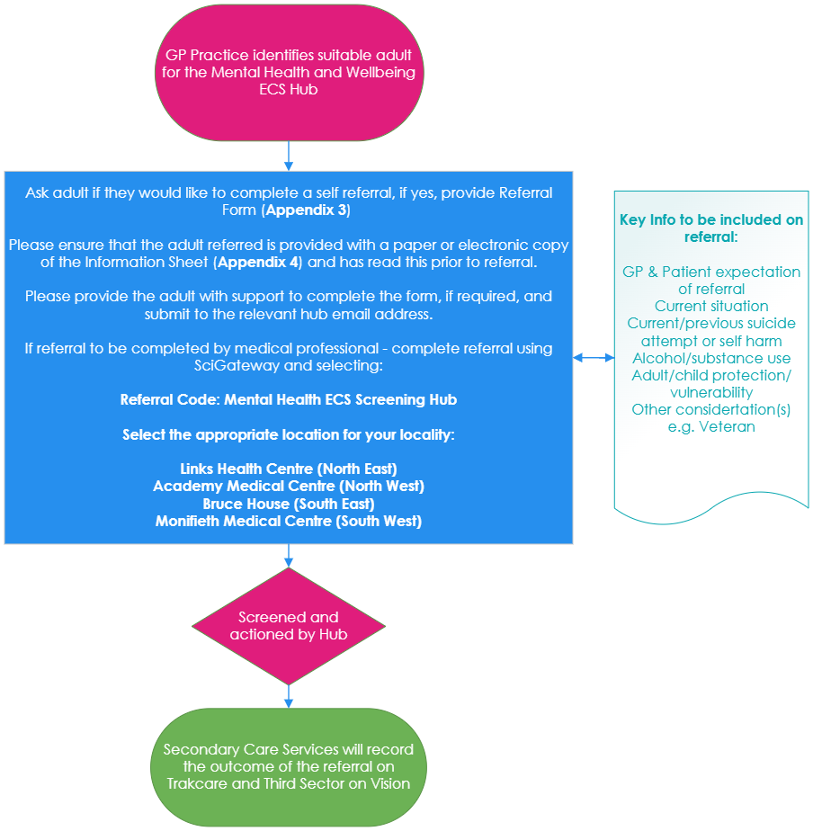

**MIIU Referral Process**

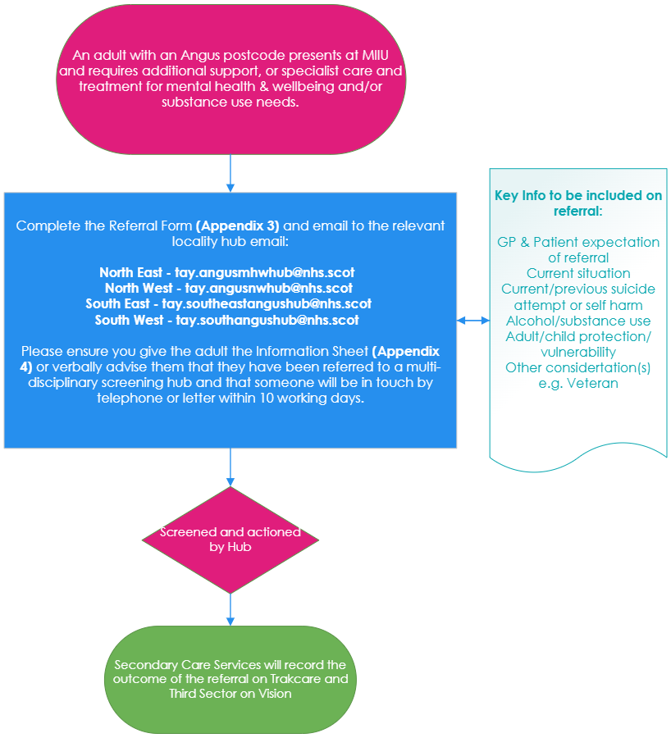

** Appendix 2**

**Angus Mental Health and Wellbeing ECS Hubs**

**REFERER INFORMATION SHEET**

**Services included in the Mental Health and Wellbeing ECS Hub are:**

**Community Link Workers (formerly known as Social Prescribers)**

* Support individuals with social issues affecting their wellbeing such as financial or housing difficulties, social isolation and loneliness, or anxiety and stress.
* Available for anyone aged 16+ registered with an Angus GP.

**Mental Health and Wellbeing Peer Support 16+**

* For individuals with mild to moderate mental health challenges.
* Offers up to three one-to-one sessions, workshops, and information drop-ins.

**Mental Health and Wellbeing Peer Support - 11-16 years olds** (attending secondary school) - referral to this service is not via the hub but by contacting the providers direct:

* **North Angus - Hillcrest Futures** - email [youngpeopleangus@hillcrestfutures.org.uk](mailto:youngpeopleangus@hillcrestfutures.org.uk) or call 01307 460101
* **South Angus – Penumbra** – email: [AngusYoungPersons@penumbra.org.uk](mailto:AngusYoungPersons@penumbra.org.uk) or call 01241 873900

**Distress Brief Intervention (DBI)**

* Provides problem-solving support and distress management for up to 14 days.
* Third-sector staff contact individuals within 24 hours of referral.

**Angus Adult Psychological Therapies Team**

* Offers 6-10 sessions of psychological intervention for mild to moderate disorders. May involve one to one or group intervention.
* Available for ages 18 to 65 years (also 16 & 17 year olds who have left school)
* For Adults Over 65 years or appropriate for referral to CMHT Older Peope – referral for Psychology should be made via standard referral procedures.

**Community Mental Health Team (CMHT)**

* Multi-disciplinary support for complex mental health needs, including crisis management, therapy, and relapse prevention.

**Angus Integrated Drug and Alcohol Recovery Service (AIDARS)**

* Provides detox services, harm reduction, psychological interventions, and carer support.
* Works closely with third-sector partners and mental health services.

**Appendix 3**

**Angus Mental Health and Wellbeing ECS Hub**

**REFERRAL FORM**

**Who is the Hub For?**

Anyone aged 16 or older living in Angus who needs support with mental health, wellbeing or substance use.

**About the Hub**

The Mental Health and Wellbeing Hub is a service that reviews referrals for individuals needing support with mental health, wellbeing, self-harm, or substance use. Staff from the following services will review your referral, Community Mental Health Teams (CMHT), Angus Integrated Drug and Alcohol Recovery Service (AIDARS), Psychological Therapies, Peer Support, and Community Link Workers. You will be contacted or offered an appointment with one of these services.

**Important Information**

By submitting this form, you consent to the sharing of your information within the Hub team.

**This form is not for urgent or emergency support. If you need immediate help, please contact your GP or emergency services.**

|  |  |  |
| --- | --- | --- |
|  | **Signed** | **Date** |
| **Please sign to confirm you understand the above** |  |  |

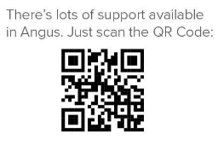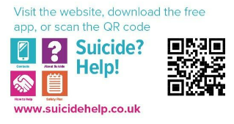



**NEXT STEPS**

**Complete and Submit the Referral Form either by:**

* Emailing it to your local Hub (email addresses are at the end of this form).
* Hand it in at your GP practice reception.

**Screening Process:**

* Your referral will be reviewed within one working day.
* You’ll receive a phone call or letter within 10 working days about the outcome.

|  |  |  |
| --- | --- | --- |
| **Type of Referral** | **DATE:** | |
| **Self-Referral**  (Please tick YES or NO) | YES | NO |
| **Completed on your behalf (with consent)**  (Please tick YES or NO) | YES | NO |
| **Have you read the Service Information leaflet** | YES | NO |
| **If this is completed on your behalf please provide further details** | Name of person  completing referral: |  |
| Relationship: |  |
| Team/Service: |  |

**PERSONAL DETAILS**

|  |  |
| --- | --- |
| **Name:** |  |
| **DOB:** |  |
| **Address:** |  |
| **Postcode:** |  |
| **Contact Number:** |  |
| **Email Address:** |  |
| **GP Practice:** |  |

|  |  |
| --- | --- |
| **Why do you want support?** | **Please tick all that apply** |
| Anxiety |  |
| Low Mood |  |
| Depression |  |
| Stress |  |
| Loneliness/Isolation |  |
| Alcohol use |  |
| Drug use |  |
| Bereavement |  |
| Housing issues |  |
| Debt/Financial Worries |  |
| Relationship difficulties |  |
| Relapsing mental health disorder |  |
| Self harm |  |
| Suicidal thinking |  |
| Other (please advise why you want support) |  |
| **For the boxes you have ticked. How does this affect you?** | |

|  |  |
| --- | --- |
| **What type of support are you looking for?** | **Please tick all that apply** |
| Advice and information |  |
| To talk to someone |  |
| Help with problem solving |  |
| Help in a crisis |  |
| Relapse prevention |  |
| Risk management |  |
| Group work |  |
| Online support |  |
| Identifying goals and how to reach these |  |
| Supporting behaviour change |  |
| Self Directed Support |  |
| Carers Support |  |
| Other (please advise of support wanted) |  |
| **Any other information you would like us to know about the support you are looking for?** | |

**Has anyone helped you in the past or is helping you now? What help have they given you?**

E.g. Family of Mental Health Support organisations, Community Mental Health Team, Penumbra, Angus Integrated Drug and Alcohol Recovery Service, Tayside Council on Alcohol, Mental Health and Wellbeing Peer Support, Psychology, Community Link Worker, Listening Service, Counselling, Carers Centre, Family, Friends.

|  |
| --- |
|  |

**Any other information you would like the hub to be aware of?**

|  |
| --- |
|  |

**Thank you for completing this referral form with as much detail as you can, to help us to provide you with the right support to meet your needs.**

**What Happens Next?**

The outcome of your referral might include:

**A Phone Call -** You may be contacted to discuss your needs and learn about available support. Please note that calls may come from an NHS blocked number.

**Pre-Appointment Tasks -** You might be asked to complete tasks such as:

* Gathering information relevant to your appointment.
* Reading helpful articles.
* Keeping a mood diary or answering questions.

Completing these tasks will help us understand your needs better and ensure you get the right support. Please bring any completed tasks to your appointment.

**Please email the completed referral form to the Hub where you live:**

**North East (Brechin, Edzell, Montrose and surrounds) -** [tay.angusmhwhub@nhs.scot](mailto:tay.angusmhwhub@nhs.scot)

**North West (Forfar, Kirriemuir, Letham and surrounds) -** [tay.angusnwhub@nhs.scot](mailto:tay.angusnwhub@nhs.scot)

**South East (Arbroath/Friockheim and surrounds) -** [tay.southeastangushub@nhs.scot](mailto:tay.southeastangushub@nhs.scot)

**South West (Carnoustie/Monifieth and surrounds) -** [tay.southangushub@nhs.scot](mailto:tay.southangushub@nhs.scot)

**Appendix 4**

**Angus Mental Health and Wellbeing ECS Hub**

**INFORMATION SHEET**

Please look at the support organisations available in your community before you refer to the hub, as they may be able to help you, you can access this information via the QR codes below:



**What is the ECS Hub?**

The ECS Hub helps people aged 16 and over who need support for mental health, wellbeing, self-harm, or substance use. A team of professionals, including nurses, social workers, psychologists, peer support workers, and community link workers, reviews each referral to connect you with the right services quickly and efficiently.

If you are an older person and you think you need mental health and wellbeing support from a peer or social prescriber please self refer to the ECS hub. If you believe that you need specialist community mental health support and you are over 65 years of age speak to your General Practitioner (GP).

**Why Use the Hub?**

The ECS Hub ensures you get the right support without having to repeat your story to different workers.

**What Happens After You Are Referred?**

Your referral will be reviewed, and you will be contacted within 10 working days by phone or letter.

**Outcome Possibilities:**

* Phone Consultation – a call to discuss your needs and available support. Calls may come from an NHS blocked number.
* Pre-Appointment Tasks - you might be asked to complete tasks (e.g., reading materials, keeping a mood diary) to prepare for your appointment. Completing these will help us support you better.

**If Your Condition Worsens**

If your mental health or substance use worsens while you wait, please contact:

* The service listed in your appointment letter.
* Your GP for further assistance.

Please see below details of what each service can provide. If you have complex needs, you may be seen by one or more of the services below to provide your support, care and treatment but this will be co-ordinated through the hub.

**SERVICE INFORMATION**

**Community Link Workers**

Community Link Workers (formerly known as Social Prescribers) work out of GP practices and help individuals connect with local support and services, or community groups and activities.

Community Link Workers aim to empower people to take an active role in improving their wellbeing. They can provide support for social issues which affect a person like financial or housing difficulties, social isolation and loneliness, or anxiety and stress. Community Link Workers use a person-centred approach and talk about what really matters to the individual. They work with people to identify the challenges they are facing and support them to set goals and overcome barriers to allow them to take greater control of their physical and mental health.

This service is available to anyone aged 16 or over, registered with a GP practice in Angus.

**Mental Health and Wellbeing Peer Support Service**

The service will provide you with support from someone who has faced their own mental health and wellbeing challenges.  The peer workers can provide emotional, practical and social support.  They will help you to access further support if required and can help with a range of self-help tools that may help improve your mental health & wellbeing.  They will share with you strategies that have worked for them during difficult times.

Because of their own experience they can relate to people who are still struggling to improve their own mental health and wellbeing.  The peer workers can provide inspiration and hope that it is possible to have a positive fulfilling future despite coping with significant challenges.

The service is aimed at people with less complex mental health and well-being challenges and will provide a maximum of three appointments.

**Distress Brief Intervention (DBI)**

Distress Brief Interventions (DBIs) are an innovative way of supporting people in distress.

Trained third sector staff will contact the adult within 24-hours of referral and provide community-based problem solving support, wellness and distress management planning, supported connections and signposting.

**Angus Adult Psychological Therapies Service**

Angus Adult Psychological Therapies team offer help to those with mild to moderate mental health problems.

Treatment is provided in a number of ways: Supported self-help, Computer based therapy, Group treatment and Individual treatment. Most treatments will encourage you to: Explore your difficulties, Agree aims for treatment, Complete tasks between appointments and Learn how to cope with difficult situations.

Your first appointment will be an assessment appointment and will last up to 60 minutes. If the assessment indicates that you would benefit from psychological intervention, treatment options will be discussed with you. Individual sessions usually last between 45 minutes and an hour and group sessions last for up to 2 hours. Treatment is time limited, and you are likely to be seen for somewhere between 6 and 10 sessions. Progress depends on regular attendance. It is therefore important that you attend all appointments given to you.

**Community Mental Health Team**

The Community Mental Health Team provides care, support and treatment for people with complex mental health needs. Support can be provided by Clinical Psychologists, Community Mental Health Nurses, Community Support Workers, Consultant Psychiatrists, Occupational Therapists and Social Workers (Mental Health).

Your first appointment would be an in-depth assessment which includes gathering information about your past history, current mental state and undertake a risk assessment and develop a risk management plan, if required. The outcome of the in-depth assessment is to work with you to agree how your ongoing needs can be best met.

It is important that you are actively involved in developing and contributing to your own health and wellbeing plan and using strategies you learn to stay well.

Services offered include to people with complex mental health needs include:

* Assessing need and care planning
* Crisis management
* Risk management
* Education and skills development
* Identifying goals and how to reach these
* Guided self help
* Supporting behaviour change
* One to one or group support
* Relapse prevention
* Problem solving skills
* Talking therapies
* Access to community support including Self Directed Support
* Medication
* Carers Support

**Angus Integrated Drug and Alcohol Recovery Service (AIDARS)**

The Angus Integrated Drug and Alcohol Recovery Service (AIDARS) is an integrated health and social work service. The team offer the following services and supports:

* Motivational and enhancement therapy
* In-patient and community detox for alcohol, opiates and opiate replacement therapy
* Recovery care planning and self-directed support
* Overdose awareness (including Naloxone dispensing), harm reduction, and BBV testing and support
* Relapse prevention in groups and one-to-one, supported by medication if required
* Psychological interventions
* Carer’s support
* All referrals to AIDARS will be assessed as to which Substance Use service would be best placed to meet a patients identified needs, and referral may be passed to Substance Use Third Sector partner: Hillcrest Futures or Tayside Council on Alcohol
* We understand that problems related to substance use and mental health and well-being can be closely linked, and we would work closely with Mental-Health and Well-being services to support you with these problems

**Appendix 4a**

**Angus Mental Health and Wellbeing ECS Hubs**

**INFORMATION SHEET – EASY READ VERSION**

Please look at the support organisations available in your community before you refer to the hub, as they may be able to help you, you can access this information via the QR codes below:



**What is the ECS Hub?**

The ECS Hub helps people aged 16 and over who need support for mental health, wellbeing, self-harm, or substance use.

**Why Use the Hub?**

The ECS Hub ensures you get the right support without having to repeat your story to different workers.

**What Happens After You Are Referred?**

Your referral will be reviewed, and you will be contacted within 10 working days by phone or letter.

**Services included in the Mental Health and Wellbeing ECS Hub are:**

**Community Link Workers (formerly known as Social Prescribers)**

* Support individuals with social issues affecting their wellbeing such as financial or housing difficulties, social isolation and loneliness, or anxiety and stress.
* Available for anyone aged 16+ registered with an Angus GP.

**Mental Health and Wellbeing Peer Support 16+**

* For individuals with mild to moderate mental health challenges.
* Offers up to three one-to-one sessions, workshops, and information drop-ins.

**Mental Health and Wellbeing Peer Support - 11-16 years olds** (attending secondary school) - referrals to this service is not via the hub but by contacting the providers direct via the contact information below:

* **North Angus - Hillcrest Futures** - email [youngpeopleangus@hillcrestfutures.org.uk](mailto:youngpeopleangus@hillcrestfutures.org.uk) or call 01307 460101
* **South Angus – Penumbra** – email: [AngusYoungPersons@penumbra.org.uk](mailto:AngusYoungPersons@penumbra.org.uk) or call 01241 873900

**Distress Brief Intervention (DBI)**

* Provides problem-solving support and distress management for up to 14 days.
* Third-sector staff contact individuals within 24 hours of referral.

**Angus Adult Psychological Therapies Team**

* Offers 6-10 sessions of psychological intervention for mild to moderate disorders. May involve one to one or group intervention.
* Available for ages 18 to 65 years (also 16 & 17 year olds who have left school)
* For Adults Over 65 years or appropriate for referral to CMHT OP – referral for Psychology should be made via standard referral procedures.

**Community Mental Health Team (CMHT)**

* Multi-disciplinary support for complex mental health needs, including crisis management, therapy, and relapse prevention.

**Angus Integrated Drug and Alcohol Recovery Service (AIDARS)**

* Provides detox services, harm reduction, psychological interventions, and carer support.
* Works closely with third-sector partners and mental health services.

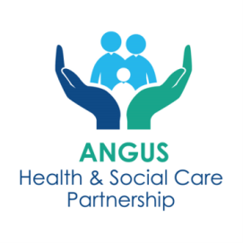**Appendix 5**

**Angus Mental Health and Wellbeing ECS Hub**

**SCREENING TOOL PATHWAY**

**When screening a referral please complete the following steps:**

**Step 1.** If the referrer has made a recommendation for a specific service and it is clear that the client is most suitable for a referral to that service:

1.1 Trackcare referral – **Go to Step 5**.

1.2 Email referral – during the meeting, forward email referral to the team who will provide support, saving a copy of sent email into relevant mailbox subfolder in hub email box

Ensure that a process is in place for emailed referrals to be added to the appropriate electronic system in your team/service area. E.g. trakcare or third sector electronic record. **Go to Step 4**.

If the screening hub disagrees with the referrer’s recommendation, or there is no recommendation, **see Step 2**.

**Referrals for older people** can be accepted at the Hub for support from Peer and Community Link Workers. For Psychiatry of Old Age (POA) referrals that come through the Hub, please forward to POA using the following email address:

[Tay.sscadmin@nhs.scot](mailto:Tay.sscadmin@nhs.scot)

**Step 2**. If the referral document has enough information to make a decision on the most appropriate service, transfer the referral on trakcare or transfer email to team who will provide support, saving a copy of sent email into relevant mailbox subfolder in hub email box.

If you cannot make a decision based on the information provided, **see Step 3.**

**Step 3**. If after reading the referral additional information is required, consider the following:

* **CONTACT THE ADULT** – To gather additional information
* **CONTACT THE REFERRER** – As above
* **CONTACT PREVIOUS WORKER (s)** – As above
* **CONSIDER ACCESSING THE FOLLOWING SYSTEMS:**
* **TRAKCARE** – To find out if a patient has recent/historic contact with Services. Click on PATIENT ACTIVITY and type in patient’s CHI number. This allows you to check current/historic referrals, are they open to a service currently, and past or present hospital admissions.
* **CLINICAL PORTAL** – Provides details of medication. Also provides details of previous diagnoses and relevant correspondence which may include recommendations.
* **EMIS** – Provides details of prior/current contact with services.
* **ECLIPSE** - can be checked for social work contact, alerts i.e. aggression, no lone working etc. A patient’s relationships can be viewed, so you can see if there are other workers involved, key relationships, legal proxy (e.g., guardians, Power of Attorney). This record will include police concern reports, adult Protection activity, Adult with Incapacity information.

**\*\*\* If there are any child protection alerts only review the adult records\*\*\***

**Step 4**. After sufficient information has been gathered to make a decision, screener to discuss and agree outcome with hub team. This must include a representative from the relevant service.

**Possible Outcomes**

* Joint appointment or one service agreeing to undertake an initial assessment then liaising with the other service.
* If waiting times are longer than 12 weeks – consider additional support and advice that can be provided and agree who will contact the adult to advise. Consider if another service can support this person meanwhile.
* If the decision is a routine referral – send a letter advising of timescales and include self-help activities, screening tools and consider requests to gather information which could enable the person referred to attend the first appointment fully prepared to support waiting well.
* If self-management information is agreed, or there is a recommendation to access a mainstream or Level 1 service. Community Link Worker or Peer to contact adult to advise and provide support to access these services, if required.

Adult can also be provided with these links <https://www.angushscp.scot/> and click on the **Are you ok?** logo on the scrolling home page to find the Mental Health Family of Resource Information.



* If referral is for another statutory service – refer in the usual way and **agree which Hub member will inform the person of the outcome.**

Trackcare referral – **Go to Step 5**.

Email referral – During the meeting, forward email referral to the team who will provide support, saving a copy of sent email into relevant mailbox subfolder.

**Step 5**. Admin to transfer referral to relevant service on trakcare if the referral is for CMHT, AIDARS, and Psychology. For Peer Support, this will be vetting outcome – Peer Support. If there is going to be a wait for support, consider whether another service or support is available to meet the person’s needs meanwhile.

Admin to complete all information including outcome information on ECS database

**Step 6**. Outcome for statutory service is on trakcare. Outcome for third sector services is on Vision.